ESTIMATION OF BUSINESS EXPENSES

INTRODUCTION:

Estimating business expenses is a crucial aspect of financial planning and budgeting for any organization. It involves projecting and quantifying the costs associated with running a business. This process helps businesses manage their finances, make informed decisions, and set realistic financial goals. To estimate business expenses effectively, you need to consider various categories, including operating expenses, employee salaries, overhead costs, marketing expenditures, and more. Accurate expense estimation is essential for creating a realistic budget and ensuring that the business remains financially viable and sustainable.

PROBLEM DEFINITION & DESIGN THINKING:

Empathy map

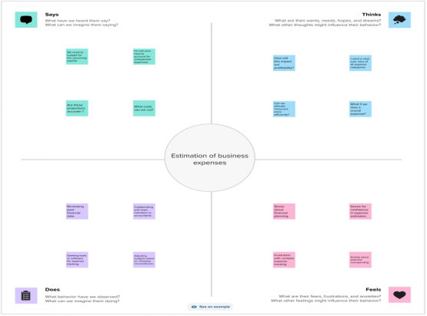

Brainstorm

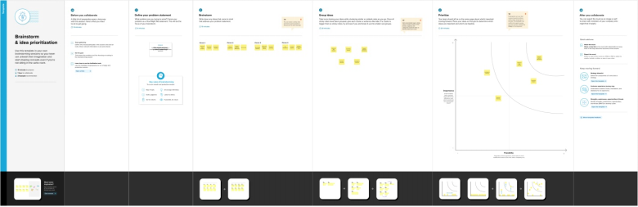

RESULT:

Dashboard: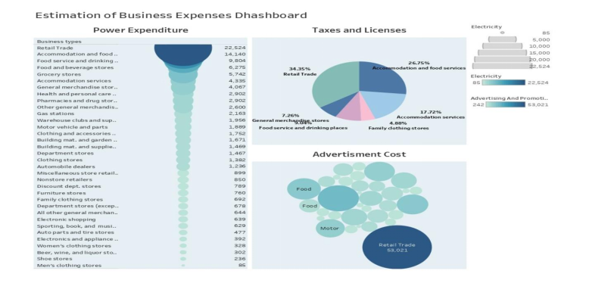

storyline: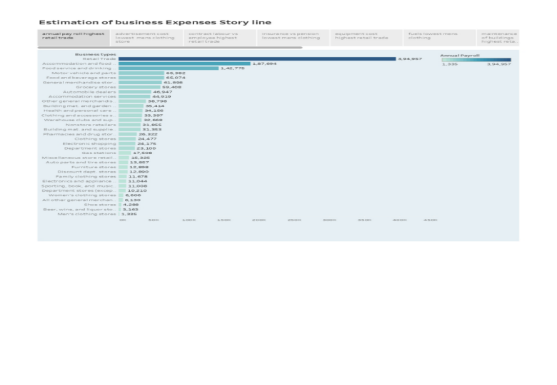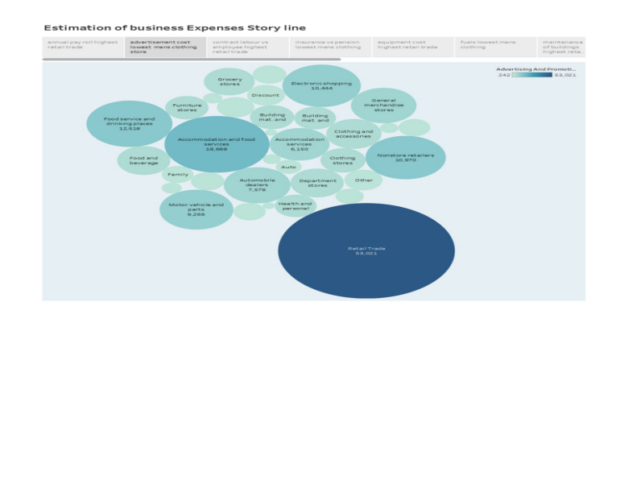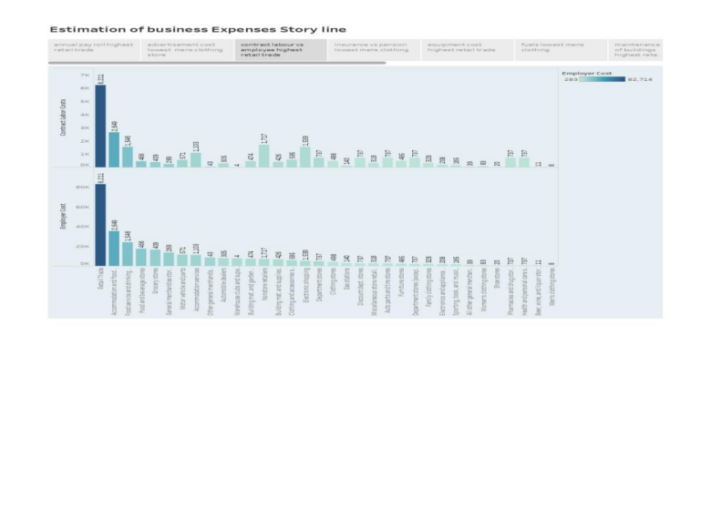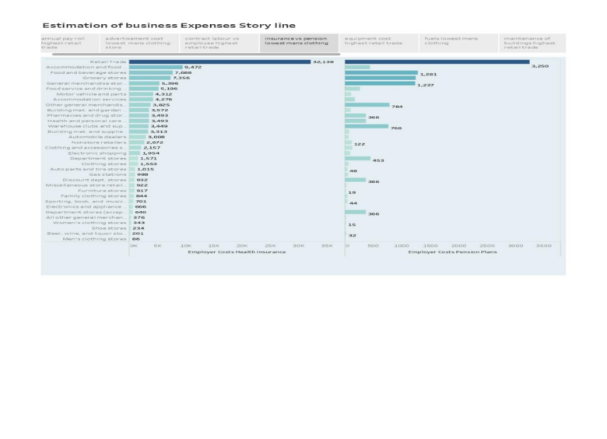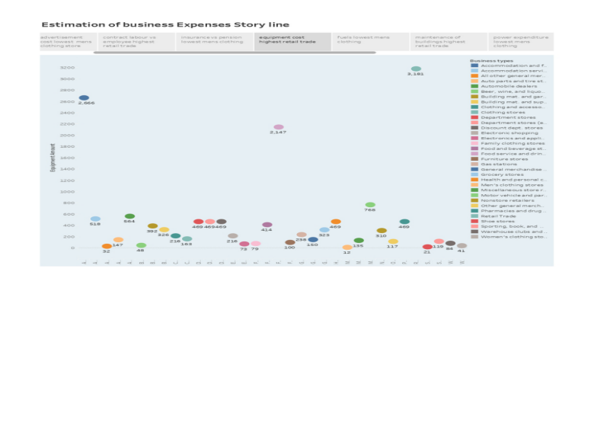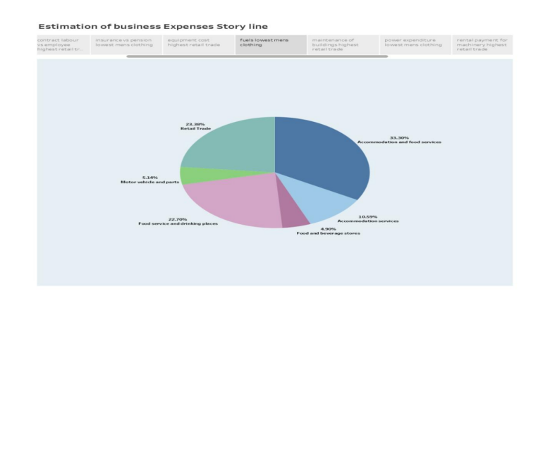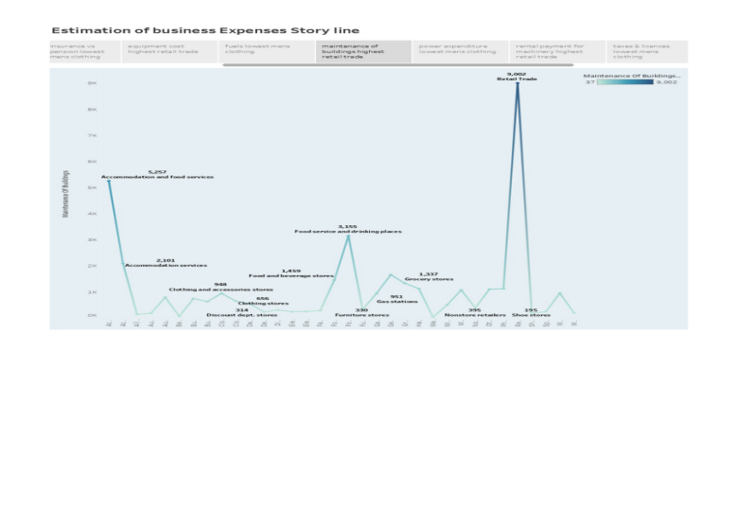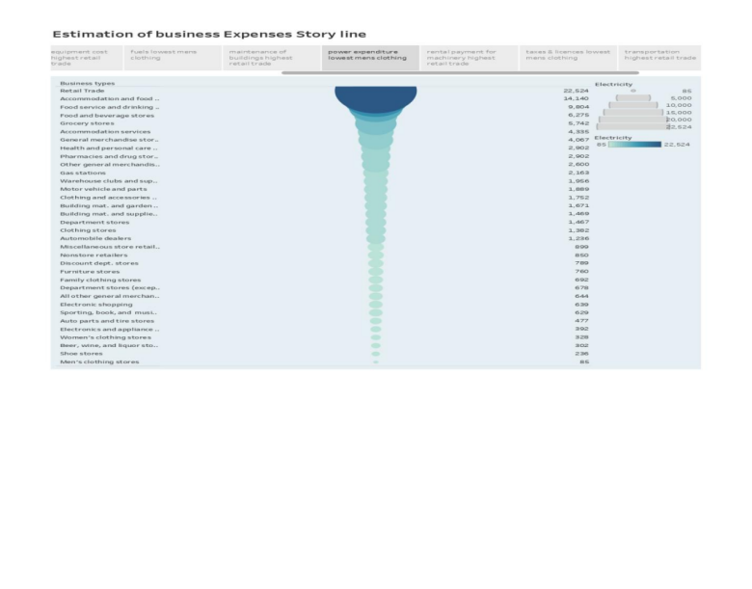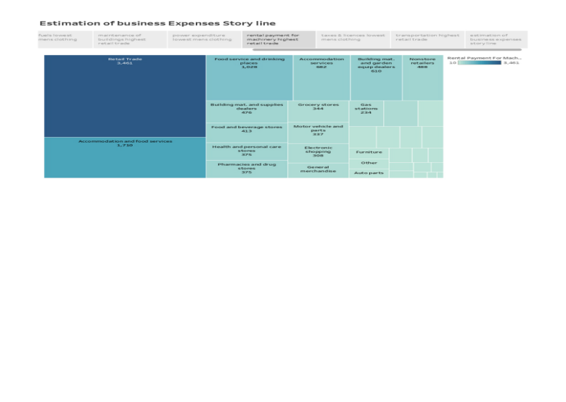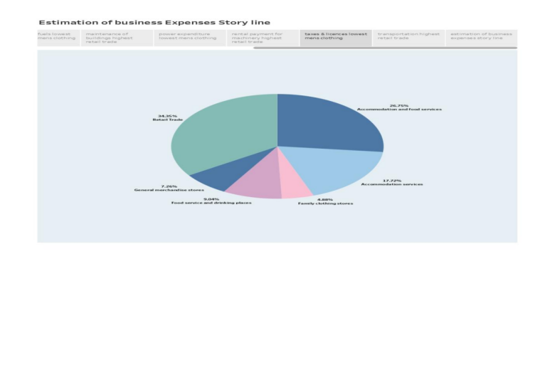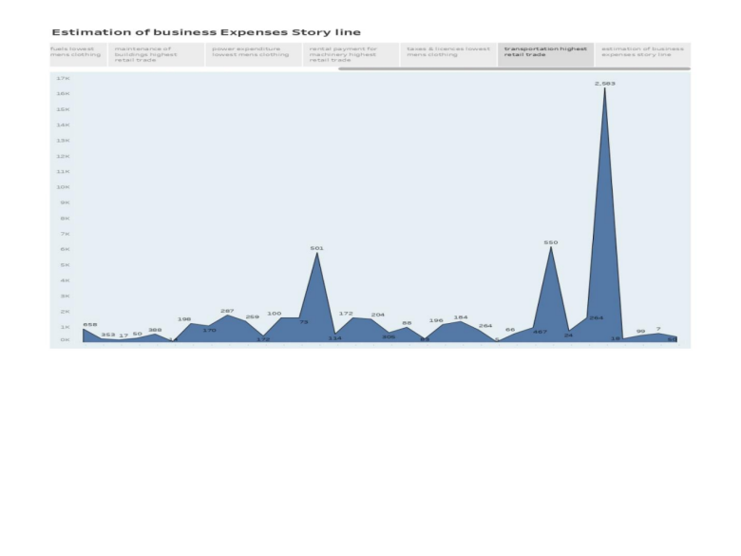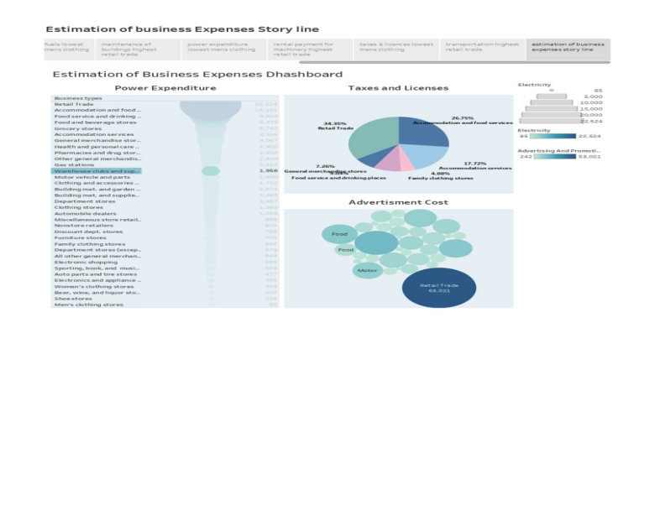

ADVANTAGES:

⇩ Financial Planning

⇩ Resource Allocation

⇩ Decision Making

⇩ Performance Evaluation

⇩ Risk Management

DISADVANTAGES:

⇩ Inaccuracy

⇩ Time and Resources

⇩ Bias and Assumptions

⇩ Overlooked Expenses

⇩ Predictive Power

APPLICATIONS:

⇩ Provide a list of common expense categories such as rent, utilities, employee salaries, office supplies, etc. Users should be able to add custom categories too.

⇩ Regularly update and maintain the application to ensure it stays current and secure.

⇩ Continuously gather feedback from users and make improvements based on their suggestions.

CONCLUSION:

Estimating business expenses is crucial for financial planning. Accurate estimation helps in budgeting, cost control, and profitability analysis. It involves forecasting various costs, including fixed and variable expenses, and should be revisited regularly to adapt to changing circumstances and market conditions.

Estimating and managing expenses will also incorporate sustainability matrics. companies will assess and budget for eco-friendly iniciatives and the costs associated with environmental complains. Automation will play a significant role in expense estimation.